**LAB REPORT NO 04**



**Systems Programming (CSE 302L)**

**Submitted By: Naveed Ahmad**

**Registration No: 22PWCSE2165**

**Section: B**

“On my honor, as student of University of Engineering and Technology, I have neither given nor received unauthorized assistance on this academic work”

Signature: __________

Date: October 27, 2024

Submitted To: Engr. Madiha Sher

**Department of Computer Systems Engineering**

**University of Engineering and Technology**

**Task 1:** Write a program that takes N UNIX commands as arguments, creates N child processes, each of them implementing their respective commands. Parent process shall wait for all the child processes and receive and print the exit status of the child processes.

Code:

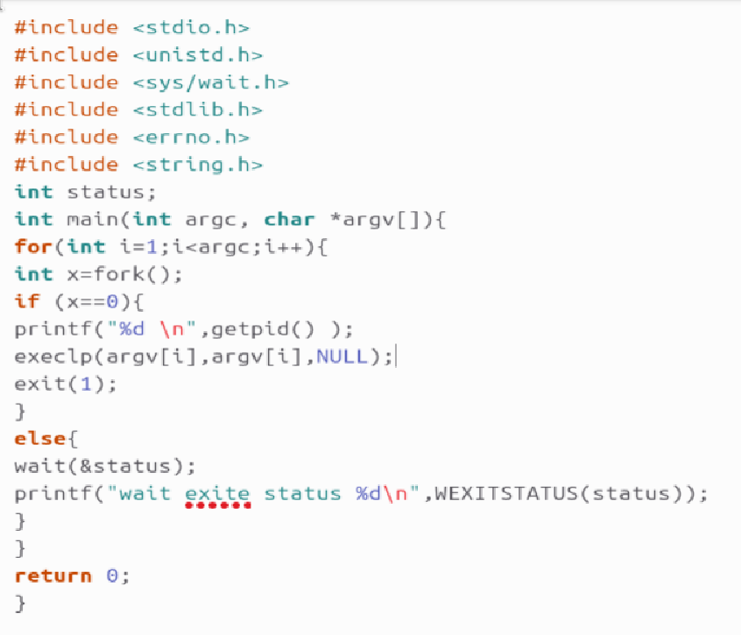

Output:

**Task 2:**

1. Write a program that takes integers as arguments and adds them.

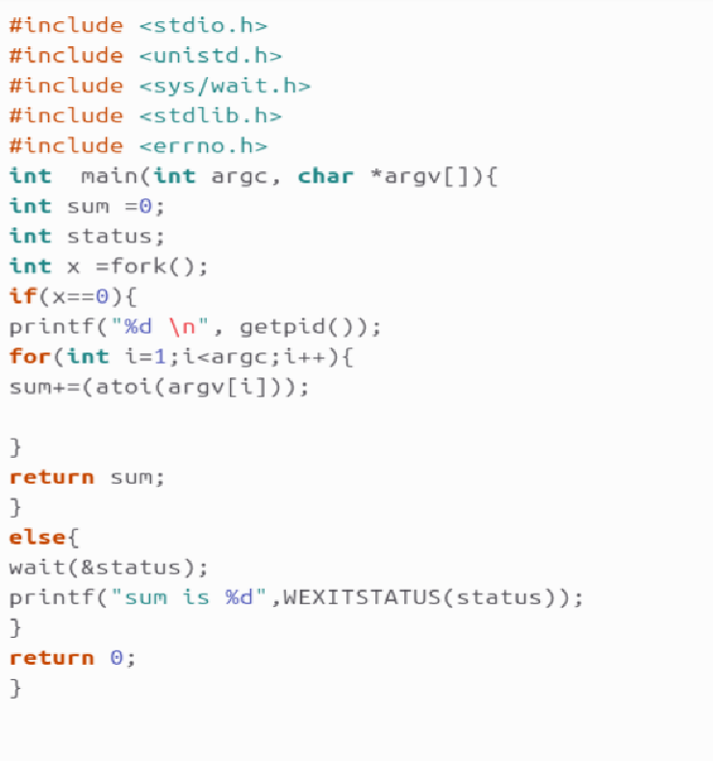

Output:

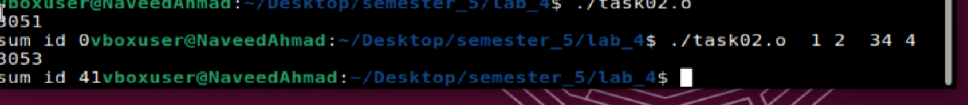

1. Write a program that takes integers as arguments and multiplies them.

Output: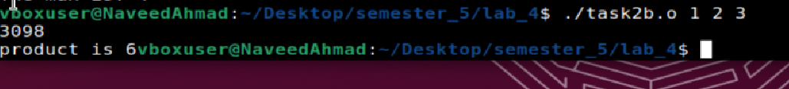

1. Write a program that takes integers as arguments & adds & multiplies them using the above two programs.

Output:



**Task 3:**

1. **Write a program “min.c” that finds the minimum value in the command line arguments and returns the value as exit status.**

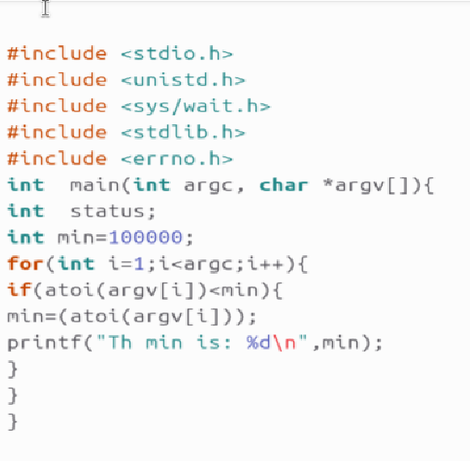

**Output:**



1. **Write a program “max.c” that finds the maximum value in the command line arguments and returns the value as exit status.**

**  
Output:**



1. **Write a program “minmax.c” that takes an array as command line arguments. Program executes min.c and max.c programs in its two child processes. The program “minmax.c” shall receive the values returned by the child processes and display these values.**

Output:

./minmax 3 5 1 9 2

**Minimum value: 1**

**Maximum value: 9**

**Task 4:**

1. **Write a program that prints the environment of the process.**

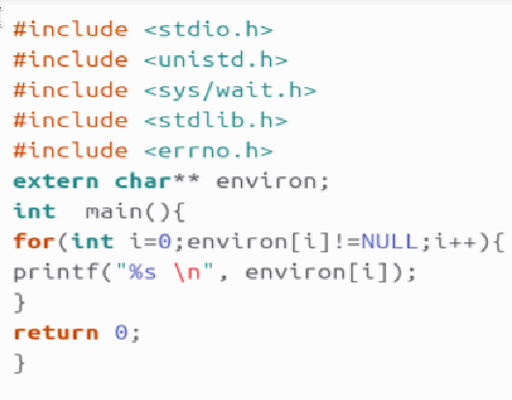

1. **Write a program that creates a child process. The child process runs the program in part a using execle/execve function. Change the environment of the child process (Change the value of one of environment variables and add a new variable named REGNO initialized with your registration number).**

**Output:**

